|  |
| --- |
| Visualforce |

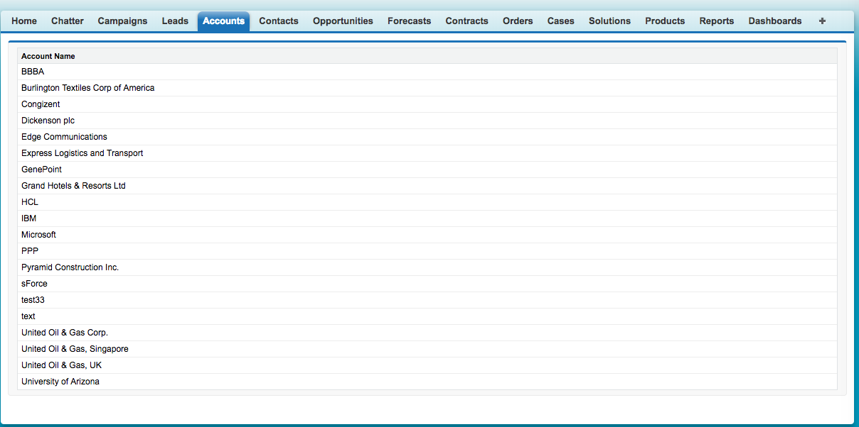

<apex:page standardController="Account" recordSetVar="anyname">

<apex:form>

<apex:pageBlock>

<apex:pageBlockTable value="{!anyname}" var="c">

<apex:column value="{!c.name}"/>

</apex:pageBlockTable>

</apex:pageBlock>

</apex:form>

</apex:page>

|  |
| --- |
| Visualforce |

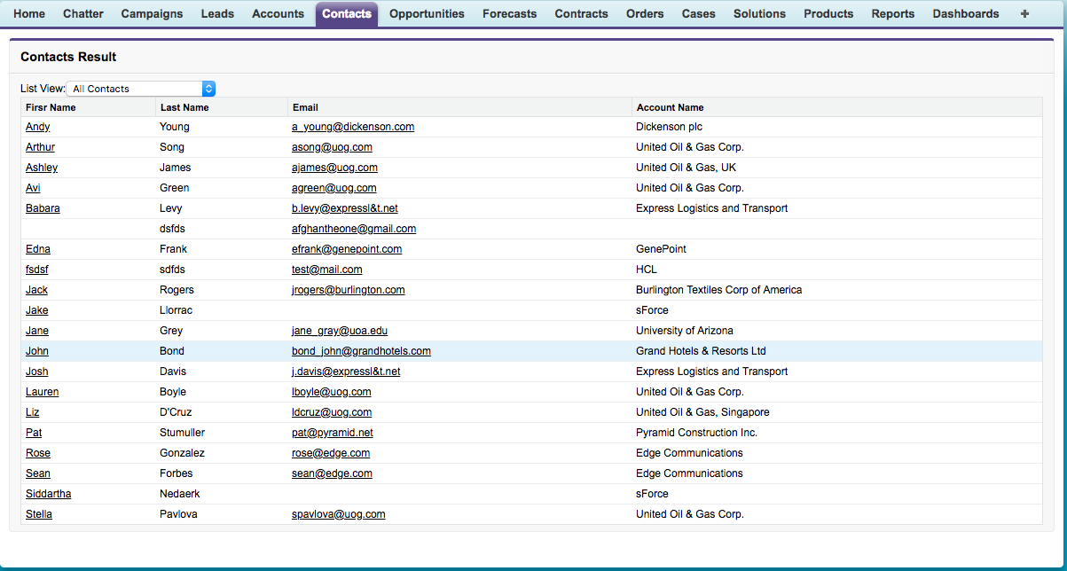

<apex:page standardController="Contact" recordSetVar="contacts" sidebar="false">

<apex:form >

<apex:pageBlock title="Contacts Result" id="contacts_list">

List View: <apex:selectList value="{! filterId }" size="1">

<apex:selectOptions value="{! listViewOptions }"/>

<apex:actionSupport event="onchange" reRender="contacts_list"/>

</apex:selectList>

<apex:pageBlockTable value="{! contacts }" var="c">

<apex:column headerValue="Firsr Name">

<apex:commandLink value="{! c.FirstName }" action="/{!c.id}"/>

</apex:column>

<apex:column value="{! c.LastName }"/>

<apex:column value="{! c.Email }"/>

<apex:column value="{! c.Account.Name }"/>

</apex:pageBlockTable>

</apex:pageBlock>

</apex:form>

</apex:page>

|  |
| --- |
| Visualforce |

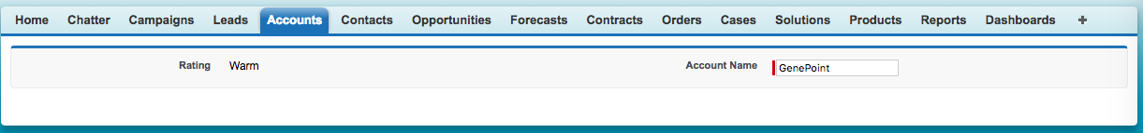

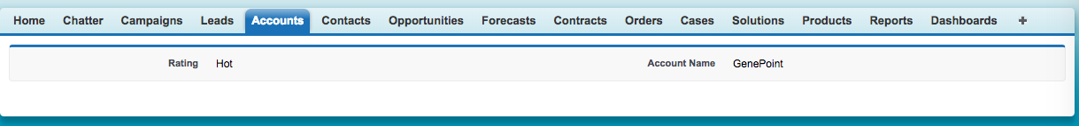

<apex:page standardController="Account" sidebar="false">

<apex:form >

<apex:pageBlock>

<apex:pageBlockSection>

<apex:outputField value="{!account.rating}"/>

<apex:outputField value="{!account.name}" rendered="{!account.rating = 'Hot'}"/>

<apex:inputField value="{!account.name}" rendered="{!account.rating = 'Warm'}"/>

</apex:pageBlockSection>

</apex:pageBlock>

</apex:form>

</apex:page>

for use this code you also need to put any account id the URL

example:- <https://c.ap5.visual.force.com/apex/samplepage?core.apexpages.request.devconsole=1&id=0017F00000gb8MU>

|  |
| --- |
| APEX |

public class SampleApexClass {

public list<Account> acclist {get; set;}

public SampleApexClass (){

acclist = [SELECT name, phone, rating FROM Account];

}

}

|  |
| --- |
| Visualforce |

<apex:page controller="SampleApexClass" sidebar="false" tabStyle="Account">

<apex:pageBlock title="List of Accounts">

<apex:pageBlockTable value="{!acclist}" var="a">

<apex:column value="{!a.name}"/>

<apex:column value="{!a.phone}"/>

<apex:column value="{!a.rating}"/>

</apex:pageBlockTable>

</apex:pageBlock>

</apex:page>

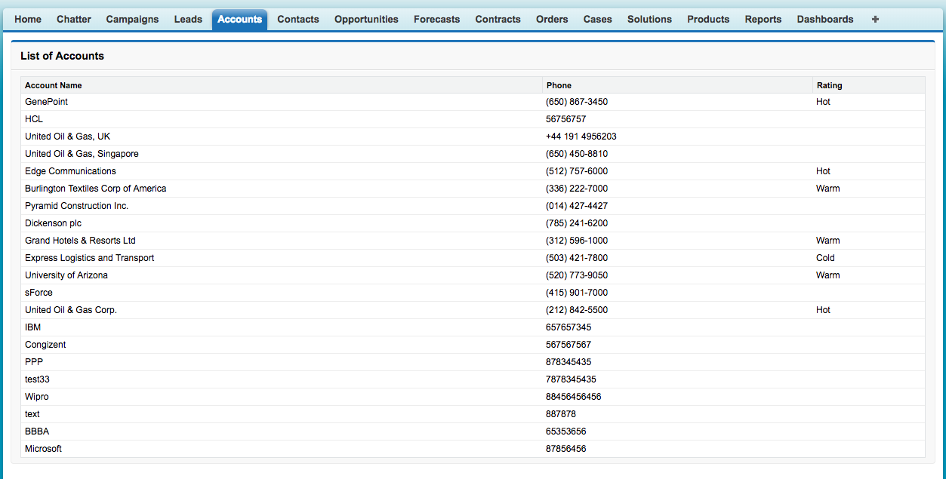

|  |
| --- |
| APEX |

public class SampleApexClass {

public list<Account> acclist {get; set;}

public SampleApexClass (){

acclist = [SELECT name, phone, rating, industry FROM Account WHERE industry = 'energy'];

}

}

|  |
| --- |
| Visualforce |

<apex:page controller="SampleApexClass" sidebar="false" tabStyle="Account">

<apex:pageBlock title="List of Accounts">

<apex:pageBlockTable value="{!acclist}" var="a">

<apex:column value="{!a.name}"/>

<apex:column value="{!a.phone}"/>

<apex:column value="{!a.rating}"/>

<apex:column value="{!a.industry}"/>

</apex:pageBlockTable>

</apex:pageBlock>

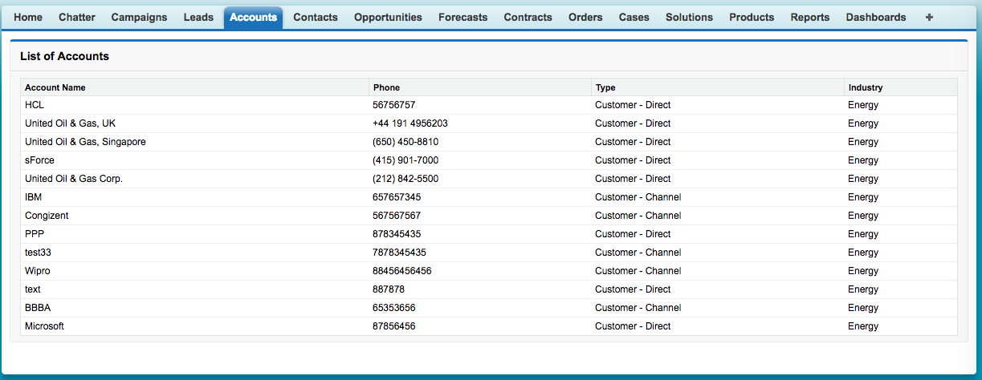</apex:page>

|  |
| --- |
|  |